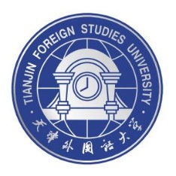
International Chinese Language Teachers Scholarship 2021

Center for Language Education and Cooperation
& Tianjin Foreign Studies University

4-week Online Chinese learning Program for Greek-Speakers

About the program:

- Time: The program commences in December 2021 (the exact date soon to be announced) and provides full scholarship.
Classes will be free for scholarship-holders.
- Platform: Zoom or WebEx.
- Classes:
    - Teaching languages:
Modern Greek & English & Chinese
    - Class Outline:
4 weeks, 10 hours/week, 2 hours/day.
- Chinese language acquisition courses
- Chinese traditional and contemporary culture courses
- A comparative study on the Chinese language and culture with the Greek language and culture. (With reference to the theoretical frameworks of Translation, Linguistics, and Pragmatics.)
- Symposium with the students of Modern Greek in Tianjin Foreign Studies University
- The program may be organized with 10-15 participants per group.

- Eligibility:
  - An HSK test score is required. (No specific requirements for the level and the score)
  - All applicants shall be citizens of Greece or Cyprus, or fluent in modern Greek

** Application procedures for the scholarship will be informed soon to eligible applicants through email. For pre-application, please fill in the form and send it to the contact email.
Deadline for the pre-application: 30th July 2021
Application Form:

Name
Surname
Nationality
ID Number
Date of Birth
(Year-Month-Date)
Passport Number
Contact Number
HSK Test Score
Students of Confucius Constitutes
(Yes or No, if Yes please specify)
Email
**Proof of the HSK test need to be sent as attachment

Contact:
ZHANG ZHAN
Email: denisezhang@tjfsu.edu.cn
zoeaileen97510@gmail.com

